

**BIORISK MANAGEMENT AUDIT CURRICULUM AND TRAINING MATERIALS DEVELOPMENT WORKSHOP AT CROWN SUITES HOTEL, MBALE**

**30thAPRIL – 4thMAY 2018**

**Report Compiled by; Ms. Atwijuka Diana &**

**Mr. Mugabe Raymond**

**1.0 INTRODUCTION**

**1.1 Background to the Curriculum Development**

The Ministry of Health, Central Public Health Laboratory (CPHL) with funding from CDC through implementing partners like Infectious Diseases Institute (IDI) with efforts to further strengthen the Biosafety Biosecurity program have organized a 5days workshop to develop a Biorisk management( BRM) audit curriculum. In addition to the harmonized BRM training curriculum and the national BRM audit checklist, the MOH identified the need of a Biosafety Biosecurity audit program towards achieving a world safe and secure from infectious disease threats especially in the face of emerging and re-emerging infectious agents. This curriculum therefore, is designed to train national BRM auditors with knowledge and skills in audit techniques tailored to BRM.

**1.2 Rationale to BRM Audit curriculum development**

Biorisk Management has grown over time with a harmonized BRM training curriculum with latest database showing over 760 laboratory personnel trained using the technical track and 350 using the basic and management tracks. April 2017, a national Biorisk audit was conducted under the arrangement of MOH and a report was launched by the state Minister for Health in charge of general duties.

Effective implementation of Biosafety Biosecurity program requires stepwise continuous audit guided improvements tailored to measure the Biorisk management interventions through mentorships, supervisions and training. Hence, there was need to improve and organize how the auditing is done and this informed the demand for Biorisk audit curriculum development, a justification for our workshop that week. The developed curriculum shall be used for training the upcoming cohort of selected Biorisk management auditors.

**1.3 Workshop Objectives**

The main objective of the workshop was to develop and consolidate a curriculum that will be used to train Auditors for the implementation of the national Biorisk Management audit program.

**Specific Objectives**

* To develop a Biorisk Management audit curriculum
* To improve the existing Biorisk Management audit checklist
* To customize the Biorisk Management audit tools for training

**2.0 Methods of Intervention Applied**

The facilitators employed a combination of service delivery methods for effective impact on their audiences and which garnered the attainment of deliverables.

• Presentations

• Visual Aids

• Formation of Discussion Groups

• Presentations from main discussion groups

**3.0 WORKSHOP PROCESSES**

**3.1: Opening Remarks**

The workshop started at 8:30 am with opening remarks by Mr. Kakooza Francis (IDI) who welcomed members to Crown suites Hotel- Mbale for the BRM audit curriculum. He requested that the workshop should begin at 8:00am to 5:00pm on a daily basis so that by the end of the five days the set objectives are achieved.

The team lead; Ms. Atwijuka Diana further highlighted what triggered the need for development of the consolidated BRM audit curriculum in addition to Kakooza’s justification. UNHLS/MOH has been conducting national Biosafety Biosecurity audits using BRM national trainers with no prior specific training in auditing hence need for independent trained BRM auditors who shall make use of the curriculum and training materials.

Mr. Nandala, Mr.Ojaku and Mr. Mulindwa, advised that there shall be a need to develop trainers’ manual, participant’s manual and PowerPoint presentations alongside curriculum development in consultation of the following Standards;

* + 1. ISO 19011: 2011 (Used for auditing)
    2. CWA 15793 (Guidelines for BRM Implementation)
    3. ISO 15190: 2003 Medical Laboratory Requirements for Safety
    4. ISO 15189: 2012 (Quality Management Systems) Clause 5.2

**3.2 Formation of Thematic groups**

The participants were divided into six groups and given assignments given. Each group worked upon the thematic area that was assigned to it. The selection of groups was based upon prior knowledge in that area.

The activities for the five days of workshop were distributed across the six group for the selected Competence areas and sections of the national BRM Audit checklist for document development. The revision of the checklist was focused on enriching the safety requirements according to the CWA 15793: 2011, ISO 15190: 2003 and ISO 15189: 2012. The 18 sections of the National BRM audit checklist were exhaustively discussed by the thematic groups according to the table below;

|  |  |  |
| --- | --- | --- |
| **Names** | **Section/area** | **Group** |
| Lenox Ebbarnezh  Onesmus Karugaba  Nanyondo Judith | * Management Responsibilities * Chemical Hazards * Health and Safety of Staff | Group one |
| Owalla Tonny Jimmy  Okello Peter  Mutaka Abdul | * Lab Premises and physical Security * Fire Prevention and Fire Protection * Lab Equipment | Group Two |
| Dr. Stella Atim  Godwin Bagashe Bagyenzi | * Storage Facilities * Laboratory Biosecurity * Waste Management | Group Three |
| Nandala Micheal  Atwijuka Diana  Mulindwa Muhamed | * Sanitation Facilities * Compressed and Liquefied Gas * Infectious Materials and Biosafety | Group Four |
| Baguma Andrew  Nambozo Harriet  Omongot Samson | * Lightening and ventilation * Electrical Hazards * Documentation | Group Five |
| Alex Ojaku  Namulindwa Christine  Amato Ojwiya | * Services * Personnal Protection * Continual Improvement | Group Six |

**3.4 Flow of the BRM Audit Curriculum Outline**

It was agreed upon by the workshop participants that the curriculum flows according to the format below;

**Overview of the Course**.

The Curriculum Rationale

Philosophy behind the curriculum

Aims, Objectives of the training program

**Course Organization**

Target audience

Duration of the course

Certification

Assessment

Resources

Monitoring & Evaluation, Framework

Expected Learning Outcome

**For word documents, they will all be presented as;**

* Font size 12
* Times New Roman
* Orientation, Justification
* Spacing 1.5
* Margin 0.5

**3.5 PRESANTATIONS BY GROUPS3.5.1Power point presentation format flow;**

The six thematic groups developed power point slides on the detailed requirements of Auditing on the sub-headings below;

* + Principles of auditing
  + Audit planning and preparation
  + Managing an audit Program
  + Performing an Audit.
  + Audit reporting and follow up

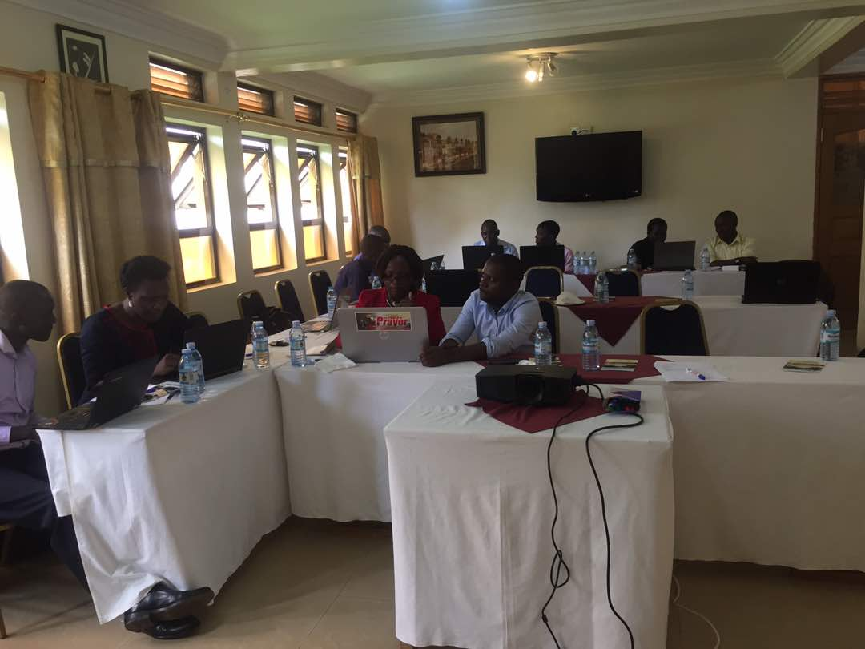

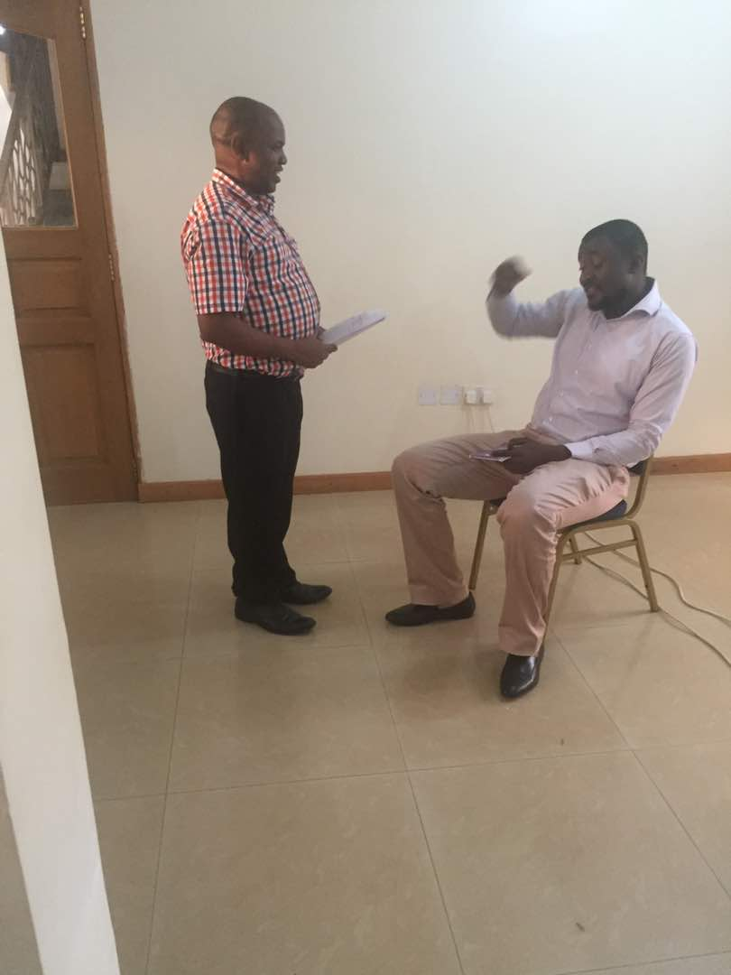

The power points slides of the above areas of competence were organized in the format below;

* Title
* Time requirements
* Learning Objectives:
* Attitude Objectives:
* Knowledge Objectives:
* Knowledge Areas to be covered:
* Content assessment
* References

**For PowerPoint Presentations, they will be developed following format,**

* Tittle: Font size 44 Left unjustified
* Body size 28 Left Justified
* Bullet type: Round Black

**3.5.2 Changes captured as revisions to the national BRM audit checklist**

On checklist unique identifier the auditors shall need to make use of Facility codes that have been assigned by Ministry of Health.

Name of Interviewer and interviewee have been replaced with name of auditor and auditee respectively.

For accreditation status the team confirmed to stating accreditation status

Level of facility additional captured National reference labs ie CPHL, NTRLP, Chemotherapeutic labs and others initially not reflected on the checklist.

Under section 2 (j) of the audit checklist under others it was agreed that it should be stated as Has the laboratory received any support supervision from management (District, facility, MoH, Partners) in relation to BRM in the past one year.

Addition of if the safety officer is part of the safety committee (section 2, part 3).

With management responsibilities in regard to budget, it has been revised as is there a work plan and budget that supports BRM activities in the laboratory.

Section 2 part 5 has been rephrased as all staff trained in BRM (Biosafety and Biosecurity)? (check for training certificate, reports)?

Section 4 (b) the word rubbish was replaced with waste.

Section 7 (e) Cleaning services (check for logs which must be updated and reviewed).

Section 7(b) Adequate backup power available in case of power outage.

Inclusion of N/A on section 11 which covers compressed and liquefied gases

Do staff use appropriate PPE while handling waste (section 16 (39)

Additional track of new changes with the audit checklist have been effected in the print out of the latest copies as on 3rd May 2018.

**CLOSING REMARKS**

Mr. Amato (National Biosafety advisor) thanked the organizers of the workshop for all the thoughts and inputs to have the workshop take effect especially the National BRM Coordinator, Mr. Atek Kagirita and the Implementing Partner (IDI) for the financial support in developing these important national documents. The most inspiring attribute is that IDI also supports other BRM related activities at the UNHLS. He concluded by wishing everyone successful travel back home.

ANNEX I; THE WORKSHOP PARTICIPANTS.

|  |  |  |  |  |
| --- | --- | --- | --- | --- |
| **S/No** | **Name** | **Designation** | **Tel. Contact** | **Institution** |
| 1 | Onesmus Karugaba | OHS Specialist | 0788182553 | MoH |
| 2 | Peter Okello | BRM Trainer | 0772379266 | UPDF |
| 3 | Owalla Tonny | BRM Trainer | 0783002781 | UNHLS |
| 4 | Mugabe Raymond | BRM Trainer | 0753808181 | UNHLS |
| 5 | Naggayi Jackie Christine | BRM Secretariat | 0705975676 | UNHLS |
| 6 | Godwin Bagyenzi Bagashe | UPDF Biorisk Officer | 0772432423 | UPDF |
| 7 | Nambozo Harriet | Lab Manager | 0704158126 | Masaka RRH |
| 8 | Nandala Micheal Wanzila | QMS Coordinator | 0773087501 | CPHL/MoH |
| 9 | Dr. Atim Stella | VET Officer | 0782449337 | MAAIF/NADEEC |
| 10 | Atwijuka Diana | BRM Trainer | 0776349464 | UNHLS/MoH |
| 11 | Ojaku Alex | QMS Trainer | 0751600216 | MOH/Lira RRH |
| 12 | Namulindwa Christine | BRM Trainer | 0782337194 | CPHL/MoH |
| 13 | Francis Kakooza | Project Coordinator | 0772437100 | IDI/GHS |
| 14 | Ebbarnezh Lennox | Fellow | 0703406037 | IDI/GHS PEP |
| 15 | Amato Ojwiya | Lab Advisor | 0772406404 | CPHL/MoH |
| 16 | Mutaka Abdul | Biomedical Engineer | 0702940240 | CPHL/MoH |
| 17 | Omongot Samson | BRM Trainer | 0776865247 | MRRH |
| 18 | Mulindwa Muhammed | Quality Assurance Specialist | 0702444475 | AGHPH |
| 19 | Atek Kagirita | National BRM Coordinator | 0782909153 | CPHL/MoH |
| 20 | Nanyondo Judith | Trainer | 0774286472 | IDI/Academy |

**ANNEX II; TIMETABLE for BRM AUDIT CURRICULUM DEVELOPMENT: 30/4/18-04/5/2018**

|  |  |  |
| --- | --- | --- |
| **DAY 1:** | | |
| Time | Activity | Lead Facilitator |
| 8:00 - 8:30am | Arrival & Registration | Administration |
| 8:30 – 9:30am | Welcome and Introduction | Francis |
| 9:30 – 9:45am | Official opening | Amato |
| 9:45- 10:30 am | Workshop Introduction and Objectives | Diana |
| 10:30 – 11:00am | Tea Break |  |
| 11:00 – 1:00pm | Overview of ; CWA 15793:2011  ISO19011:2011  ISO15189:2012  ISO15190: 2003 | Nandala |
| 1:30 – 2:30pm | Lunch Break |  |
| 2:30 - 5:00pm | Discussions;  Activity 1;Sketch of the Curriculum  Activity 2; Review of the national BRM checklist | Group Work  Nandala    ALL |
| **DAY 2** | | |
| 8:30 - 10:30am | Discussion on competence areas of Auditing   * Introduction to auditing * Principles of auditing * Managing an audit program * Preparation and planning an audit * Conducting BRM audit * Report writing * Handling non- conformities * Competency evaluation for auditors * Presentation skills | ALL  Groups; |
| 10:30 -11:00am | Tea Break |  |
| 11:00 am - 1:00 pm | Continuation of group discussions on competence areas of Auditing |  |
| 1:00 - 2:00pm | Lunch Break |  |
| 2:00 – 4:00pm | Presentation of the generated content on the competence areas of auditing | All groups |
| 4:00 - 5:00pm | Wrap Up and Day’s Evaluation | Muhammed |
| **DAY 3** | | |
| 8:30- 10:30am | Developing the PPT modules | Muhammed |
| 10:30-11:00am | Tea Break |  |
| 11:30-12:00pm | Developing the Participant’s manual | Nandala |
| 1:00-2:00pm | Lunch Break |  |
| 2:00- 4:00pm | Presentation of the Facilitator’s manual | Nandala |
| 4:00 - 5:00pm | Day’s Evaluation | Godwin |
| **DAY 4** | | |
| 8:30 – 10:30am | Presentation of the draft curriculum | Nandala |
| 10:30 – 11:00am | Tea Break |  |
| 11:00 – 1:00pm | Reactions to the draft curriculum presentation | ALL |
| 1:00 – 2:00pm | Lunch Break |  |
| 2:00- 5:00 Pm | Presentation of final BRM audit curriculum | Nandala |
| **DAY 5** | | |
| 8:30- 9:30 am | Monitoring and Evaluation (M&E for BRM) | Alex & Muhammed |
| 9:30- 10:30 am | Compilation of the Pre/ post assessments |  |
| 10:30 – 11:00am | Tea Break |  |
| 11:00 am – 1:00pm | Discussions & Job aids | ALL |
| 1:00 – 2:00pm | Lunch Break |  |
| 2:00-3:00pm | Road map and way forward & Closure | Atek / Amato |